Thomke Mayer Artwork "1Q84" Visual Analysis Essay
Name
Institution

Introduction
Artists have used artwork illustrations as an excellent way to encompass most of the human life aspects such as clothes, buildings, music, and our surrounding environments. As an old form of communication for human beings, artwork represents how humans have communicated and describes the human lives from the oldest history. It has remained and still remains an integral part of humanity. One of Thomke Mayer’s Artwork named 1Q84 shown below is an illustration of depicts a homestead located in a city with a man admiring the golden sky of a sun set on a playground slide on the compound. This illustration depicts connects the environment with humanity and depicts nature as a source of human comfort and peace. At the same time, this illustration depicts an urban struggle for humanity to have an efficient access to the natural gifts such as sun and sky beauty. It presents a struggle for a city dweller to have maximum enjoyment of the nature at their comfort. 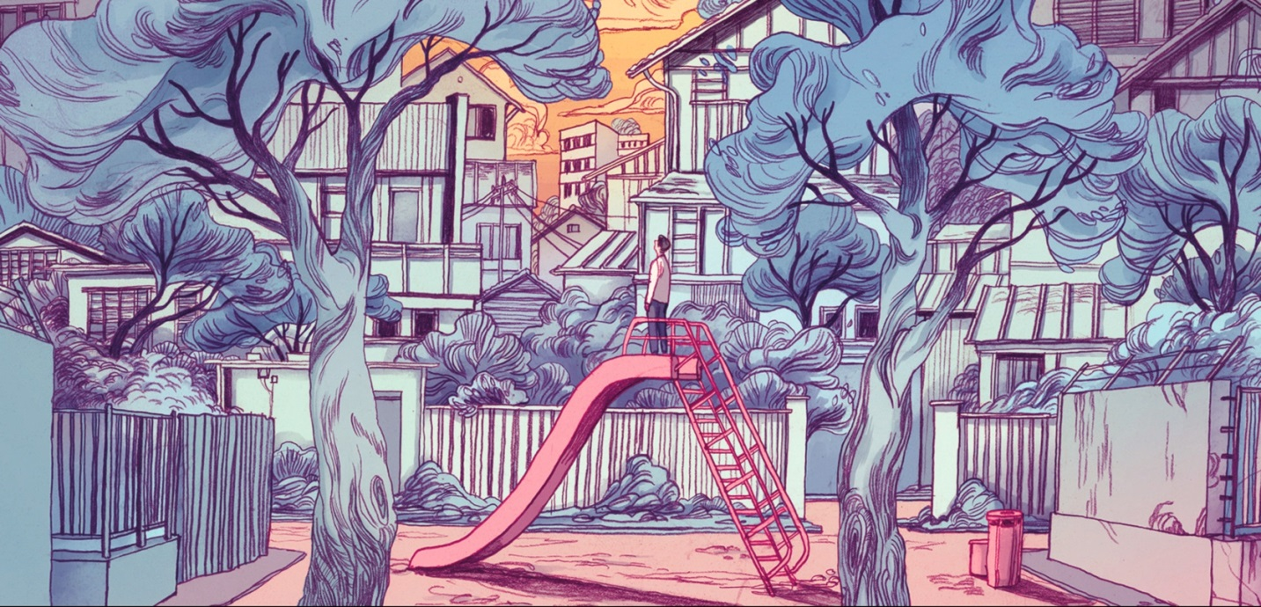
Artwork name: “1Q84’’
Artist name: Thomke Mayer Artwork
To begin with, the composition of this illustration is greatly done to bring the attention the viewer to the main focus. The main focus of this illustration is the person standing on the playground slide. This person is placed at the center of the illustration and surrounded by the other visual elements of this illustration. Placing the person on this position directs the focus of the viewer toward the human being and shows how he connects with his surrounding environment. The human being in this illustration is surrounded by buildings trees and fences. This also creates a sympathetic mood towards this person. The person is shown as being enclosed in a small confinement and lacks the freedom to explore his environment freely.
The artist has as well exploited several elements of design to effectively express the message in this illustration. Some of the most important aspects that the artist utilizes in this work include colors, size, shape, line, texture as well as value. For instance, the size and shape element have been combined in the image of the human being to represent the person as weak and defeated. The person I represented in a small size, which shows him as an inferior character in his environment.
The person is also presented in a manner that shows that he is not fully satisfied. The way he stands on the slide clearly shows that he is not intending to enjoy the slide but looking to achieve something else. He also drops his hands and stands in a posture that indicates more of a defeat. Besides, the way the person looks up in the sky with a bent neck shows that the person desperately need to have a view of the sky.
The probable reason for the person going up on top of the playground slide is because he could not have accessed the view of the sky from the ground for he is blocked by the tall buildings above him. The artist also shows a very small part of the sky that is visible. That means that despite his efforts to try to reach to the environment, he can still not have an adequate access to it. That also explains his struggle shown in this illustration.
The artist has also used the aspect of shapes and lines to direct our eyes to some important elements in this illustration. The eyes of the viewers are attracted to familiar shapes and lines and drive their focus towards certain areas of the artwork. In this illustration, the triangular shape of the slide perfectly draws the attention of the viewer to the top of it, where a person stands. The lines of the stairways towards the top of the slide also drive the focus of the viewer toward s the person on top of the slide.
The illustration also utilizes the use of shapes that provide more details on the composition of the image. For instance, the artist dominantly uses rectangular shapes to define some of the most important elements in this illustration. The shapes define such things as the compound, the fences, the buildings and the entryway to the compound. The lines of the electric cables drive the attention of the viewers to the sky, which is an integral part of this illustration’s composition and the message.
The design aspect of color is also dominantly utilized in this illustration. The gray color is dominant in this illustration. Psychologically, this color means loss and may also indicate depression. The human being in this illustration is depicted as a person who has lost the beauty of nature to urbanization. All the natural features such as vegetation have been occupied by buildings. The color also shows that the atmosphere is dirty and has no fresh air. This is a common problem in modern urban dwellings.
The reddish orange color of the ground also depicts the lack of vegetation on the ground. This color is also used predictably to shoe that the ground is turning red, as an indication of impending danger; the danger of lack of vegetation on the ground, which is environmental degradation. The golden color on the sky means indicates time. This color shows that the action on the illustration takes place during an evening sunset. The golden color is also used symbolically to show the great value of nature to human being. The person on the illustration is shown desperately seeking to get in touch with this great value.
In conclusion, while Thomke Mayer Artwork in this illustration represents a great work and shows the value of environment and nature to human being, the work seems to be a criticism on the idea of urbanization and its negative impacts not only to the nature but also to human beings. The artist utilizes the juxtaposition of dirty environment and dry grounds to represent the metaphor of the negative impacts of urbanization. The use of a human being clinging unto the sky shows how the urban population misses the opportunity to enjoy free gifts of nature such as sunlight, breezes, fresh air as well as general beauty of natural environment.

